**PROJECT REPORT**

**ON**

**EXAMINATION MANAGEMENT SYSTEM**

Submitted in partial fulfilment of the requirement for the Course FSE (22CS037) of

**COMPUTER SCIENCE AND ENGINEERING B.E.**

**Batch-2022**



**Under the Guidance of :**

Rahul Singh Rajput

**Submitted By:** Nimish Sharma -2210991986

Prabhdeep Singh Bhatia -2210992050

**DEPARTMENT OF COMPUTER SCIENCE AND ENGINEERING**

# CHITKARA UNIVERSITY

## CERTIFICATE

This is to be certified that the project entitled “Examination Management System” has been submitted for the Bachelor of Computer Science Engineering at Chitkara University, Punjab during the academic semester Jan 2025 July-2025 is a Bonafede piece of project work carried out by “Nimish Sharma (2210991986),Prabhdeep Singh Bhatia (2210992050)” towards the partial fulfilment for the award of the course

Integrated Project (CS 203) under the guidance of “Rahul Singh Rajput”.

**Sign. of Project Guide**:

Rahul Singh Rajput

(Trainer & CSE)

## CANDIDATE’S DECLARATION

I, **Nimish Sharma (2210991465), Prabhdeep Singh Bhatia(2210992050)** B.E.-2022 of the Chitkara University, Punjab hereby declare that the Project entitled **“**Examination Management System**”** is an original work and data provided in the study is authentic to the best of our knowledge. This report has not been submitted to any other Institute for the award of any other course.

|  |  |  |
| --- | --- | --- |
|  |  |  |
| **Sign. of Student 1** |
| Nimish Sharma |
| ID No 2210991986    **Sign. of Student 2**  Prabhdeep Singh Bhatia  ID No 2210992050 |

**Place: Chitkara University**

**Date: 16April, 2025**

## ACKNOWLEDGEMENT

It is our pleasure to be indebted to various people, who directly or indirectly contributed in the development of this work and who influenced my thinking, behavior and acts during the course of study.

I express our sincere gratitude to all for providing me an opportunity to undergo Integrated Project as the part of the curriculum.

I am thankful to “Rahul Singh Rajput” for his support, cooperation, and motivation provided to us during the training for constant inspiration, presence and blessings.

I also extend our sincere appreciation to ***“***Rahul Singh Rajput***”*** who provided his valuable suggestions and precious time in accomplishing our integrated project report.

**Nimish Sharma**

**ID No 2210991986**

**Prabhdeep Singh Bhatia**

**ID No 2210992050**

### INDEX

|  |  |  |
| --- | --- | --- |
|  |  | **Page No.** |
|  | **Acknowledgement** | **4** |
|  | **Abstract/keyword** | **6** |
|  | **Introduction** **/Problem Statement** | **7-8** |
|  | **Software & Hardware**  **Requirements** | **9-10** |
|  | **Database Analysing, Design &**  **Implementation** | **11** |
|  | **Code Implementation & Database Connection** | **14** |
|  | **Program Structure & Snapshots** | **15-18** |
|  | **Limitation** | **19** |
|  | **Conclusion** | 19 |
| **10.** | **Future Scope & References** | **19** |

## 1. Abstract/Keywords

Examination Management System project presents a comprehensive examination website developed using the MERN stack (MongoDB, Express.js, React.js, Node.js). The application is designed to assist users in courses,test and result of their students effectively by providing tools for creating courses, tests and attempting tests. The website features a user-friendly interface with responsive design, ensuring accessibility across various devices.

User authentication and data encryption are implemented to ensure security and privacy, with role-based access control for multi-user environments.

The backend leverages a NoSQL database (MongoDB) for flexible data storage, while the frontend is powered by React.js, offering dynamic and interactive user experiences. This Examination platform aims to empower users with actionable insights into their scores, supporting both examiners and student needs.

## 2. Introduction to the Project

In the modern education system, digital assessment platforms play a crucial role in streamlining the examination process. This project, Online Examination Platform, is designed to provide a structured and efficient way to manage online tests, ensuring seamless coordination between administrators, examiners, and students.

Built using the MERN (MongoDB, Express.js, React.js, Node.js) stack, this platform enables admin users to create courses and assign them to examiners. Examiners can then create and manage tests, performing CRUD (Create, Read, Update, Delete) operations on questions. Students can take assigned tests, and view their results upon completion.

The system ensures a smooth examination process by incorporating secure authentication, automated result calculation, and real-time test management. With an intuitive user interface and a structured workflow, this platform enhances the efficiency of online assessments while maintaining transparency and accuracy.

### 2.1 Background

With the increasing popularity of digital learning and online assessments, traditional quiz and examination methods often face challenges such as limited accessibility, manual evaluation inefficiencies, and lack of engagement. To overcome these issues, many educational platforms and organizations are adopting **online quiz applications** that offer a structured, automated, and interactive approach to conducting assessments.

This project, **Master Quiz**, is designed as an **online quiz platform** using the **MERN (MongoDB, Express.js, React.js, Node.js) stack**. The platform enables administrators to manage quizzes by performing CRUD (Create, Read, Update, Delete) operations on quiz questions. Users can register, log in, select quiz topics, answer questions, and view their scores instantly.

By incorporating **real-time quiz processing, user authentication, and result tracking**, this platform ensures a secure, engaging, and user-friendly experience for quiz-takers. The system provides instant feedback on answers and tracks user performance, making it an effective tool for **learning, practice, and self-assessment**.

This project aims to modernize traditional quiz systems by **offering an interactive, scalable, and efficient solution** for conducting online quizzes across **educational institutions, competitive exam preparation, and corporate training**.

### 2.2 Problem Statement

Traditional quiz and assessment methods often face several challenges, including **manual question management, inefficient evaluation processes, limited accessibility, and lack of real-time feedback**. These limitations make it difficult for educators, trainers, and learners to engage in effective knowledge assessment.

With the increasing demand for **online learning and digital evaluation**, there is a need for an **interactive and automated quiz platform** that simplifies quiz creation, enhances user engagement, and provides instant results.

This project, **Master Quiz**, aims to solve these challenges by developing a **MERN-based online quiz system** that allows users to **register, take quizzes, and track their performance**, while administrators can **create, manage, and update quiz questions easily**.

By leveraging modern **web technologies** and integrating features like **user authentication, quiz result tracking, and a structured question database**, this project provides a **scalable, efficient, and user-friendly** solution for **students, educators, and training organization.**

## 3. Software and Hardware Requirement Specification

### 3.1 Software Requirements

**Operating System:**

* Windows 10/11, macOS, or Linux (Ubuntu recommended for deployment)

**Frontend Development:**

* React.js: For building the user interface and handling client-side logic.
* Bootstrap: For designing a responsive and modern user interface.

**Backend Development:**

* Node.js: For server-side scripting and managing backend logic.
* Express.js: For building the RESTful API that communicates between the frontend and the backend.

**Database:**

* MongoDB: For storing user details, courses, tests, questions for each test, result of each test for every student

**Development Environment**:

* Visual Studio Code (VS Code): Recommended IDE for coding.
* Node Package Manager (npm) or Yarn: For managing dependencies and packages.
* Postman: For testing API endpoints and backend services.

### 3.2 Hardware Requirements

**Development Machine:**

* Processor: Intel Core i5 or equivalent AMD processor.
* RAM: Minimum 8 GB (16 GB recommended for smoother multitasking and faster builds).
* Storage: At least 256 GB SSD (Solid State Drive) for faster read/write speeds and storage of project files.
* Graphics: Integrated graphics are sufficient, but a dedicated GPU (like NVIDIA or AMD) can be beneficial for handling intensive tasks.

**Networking:**

* High-Speed Internet: For development, testing, and deployment tasks, ensuring seamless collaboration and deployment.
* Router with Good Bandwidth Support: To handle data transmission during development and testing phases, particularly when dealing with cloud services and real-time APIs.

## 4. Database Analysing, Design, and Implementation

* **Data analysis:** Identify the key entities and relationships.
* **Database implementation:** Implement the database schema using mongoDb.

1. Users Table:

* name
* email
* password
* role

2. Courses Table:

* title
* description
* examiner
* tests

3. Test Table:

* course Id
* examiner
* title
* description
* duration
* type
* questions
* passing Score
* scheduled Date
* start Time
* retake Allowed
* retake Limit

## 5. Program’s Structure Analysing and GUI Constructing (Project Snapshots)

* **Wireframing:** Create visual representations of the user interface.
* **Prototyping:** Develop interactive prototypes to test the user experience.
* **GUI development:** Implement the user interface using Bootstrap and JavaScript(with a framework like React).

The structure of the Examination Portal is critical to ensuring that the application is modular, maintainable, and scalable. The system is developed using the MERN stack, which includes MongoDB, Express.js, React.js, and Node.js. Each component of this stack plays a distinct role in the architecture, working together to deliver a seamless user experience and efficient backend processing.

### 5.1 Application Architecture

**Presentation Layer (Frontend)**

* React.js: This is the frontend framework responsible for building the user interface (UI). React.js is used to create reusable UI components, manage user interactions, and handle the state of the application.
* Bootstrap: Bootstrap is used in conjunction with React to style the application. It allows for rapid UI development with utility-first CSS classes, ensuring the interface is both visually appealing and consistent.

**Application Logic Layer (Backend)**

* Node.js: Node.js serves as the runtime environment for the server-side application. It handles the execution of JavaScript code on the server, managing client requests and responses.
* Express.js: Express.js is the web application framework used with Node.js to create RESTful APIs. It simplifies the process of routing, middleware integration, and handling HTTP requests.

**Data Layer (Database)**

* MongoDB: MongoDB is a NoSQL database used to store and manage application data. Its document-oriented structure is particularly well-suited for the complex, hierarchical data used in the DD, such as patient records, appointments, and medical history. MongoDB’s flexible schema design allows for easy updates and scaling as the application grows.

### 5.2 Component-Level Analysis

Each layer is composed of several components, each with a specific role within the system. The following section breaks down the key components within each layer:

**Database Components:**

* Collections: MongoDB collections store entities like user, email, password. Each fields is designed to get user details which further helps in providing better user experience.
* Schemas and Models: MongoDB models define the structure of the data stored for user login/register, courses retrieval ,test retrieval , displaying questions including the data types and validation rules. These models are implemented in the Node.js application using Mongoose.

### 5.3 Workflow Analysis

**User Roles**

**a. User**

* Register/Login: User can create accounts and log in to the system.
* Admin Dash board -If user role is Admin, it will navigate to user dashboard where user can create or delete courses.
* Examiner Dashboard - If the user role is Examiner, they will be navigated to the Examiner Dashboard, where they can create, update, and delete tests for the assigned courses. Examiners can also add, modify, and remove questions within a test and set parameters such as duration, total marks, and grading criteria.
* Student Dashboard - If the user role is Student, they will be navigated to the Student Dashboard, where they can view available tests for their enrolled courses, attempt tests, and view their results after completion. Students can also track their performance history, check scores, total marks, pass/fail status, and review test details.

## 6. Code Implementation and Database Connections

The code implementation phase involves translating the system’s design into functional software components. This includes setting up the environment, writing the code for both frontend and backend, and ensuring seamless integration with the database. The following section outlines the key aspects of the code implementation and how database connections are established and managed.

**6.1 Backend development:**

**Environment Setup**

* **Install Node.js and npm:** Node.js provides the runtime environment for executing JavaScript on the server, while npm (Node Package Manager) is used to manage dependencies.
* **Install MongoDB:** MongoDB serves as the database where all the data related to users Registered and logged in can be stored.
* **Set Up React App:** Create the React.js project using create-react-app, which sets up the initial project structure and dependencies.

**Backend Code Implementation (Node.js/Express.js)**

The backend is responsible for handling requests from the frontend, processing them, interacting with the database, and sending the appropriate responses.

* **Setting Up Express.js Server**

The Express.js server is the core of the backend, handling HTTP requests and routing them to the appropriate endpoints.

* **Connecting to MongoDB**

Establishing a connection to MongoDB is crucial for data storage and retrieval. Mongoose.

* **Defining Models and Schemas**

MongoDB models define the structure of the documents within each collection.

* **API Endpoints**

Express.js routes are set up to handle different HTTP requests (GET, POST, PUT, DELETE). These routes interact with the MongoDB database through the models.

**6.2 Snapshots**

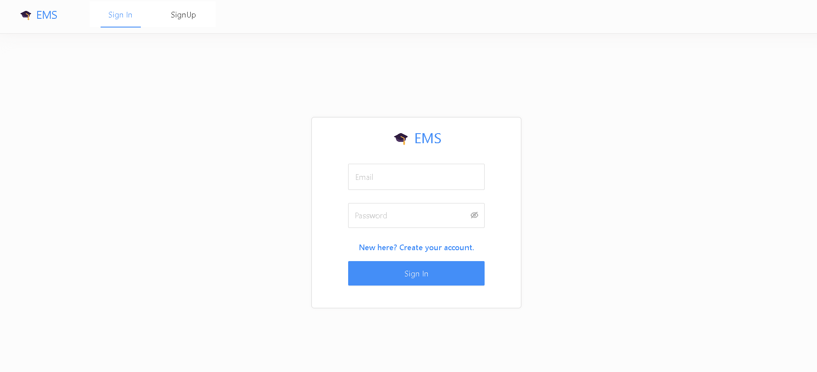

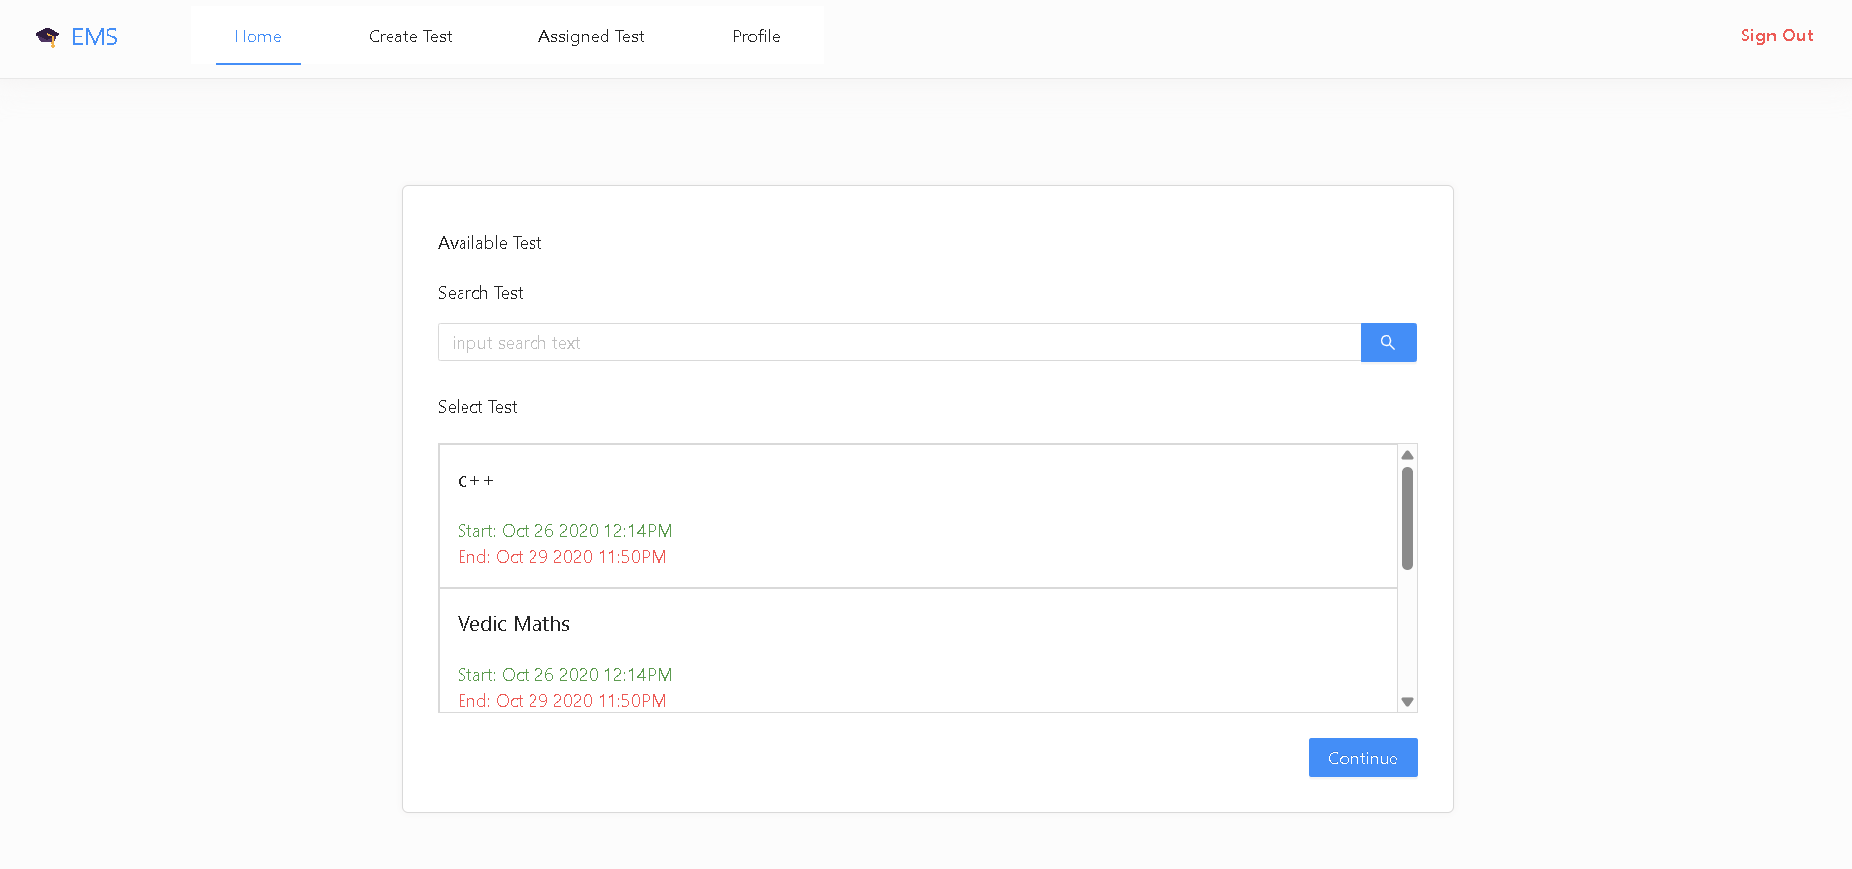

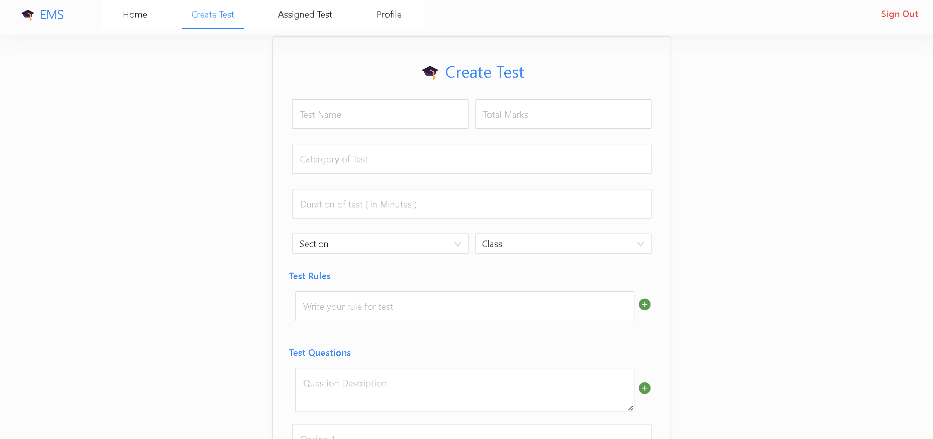

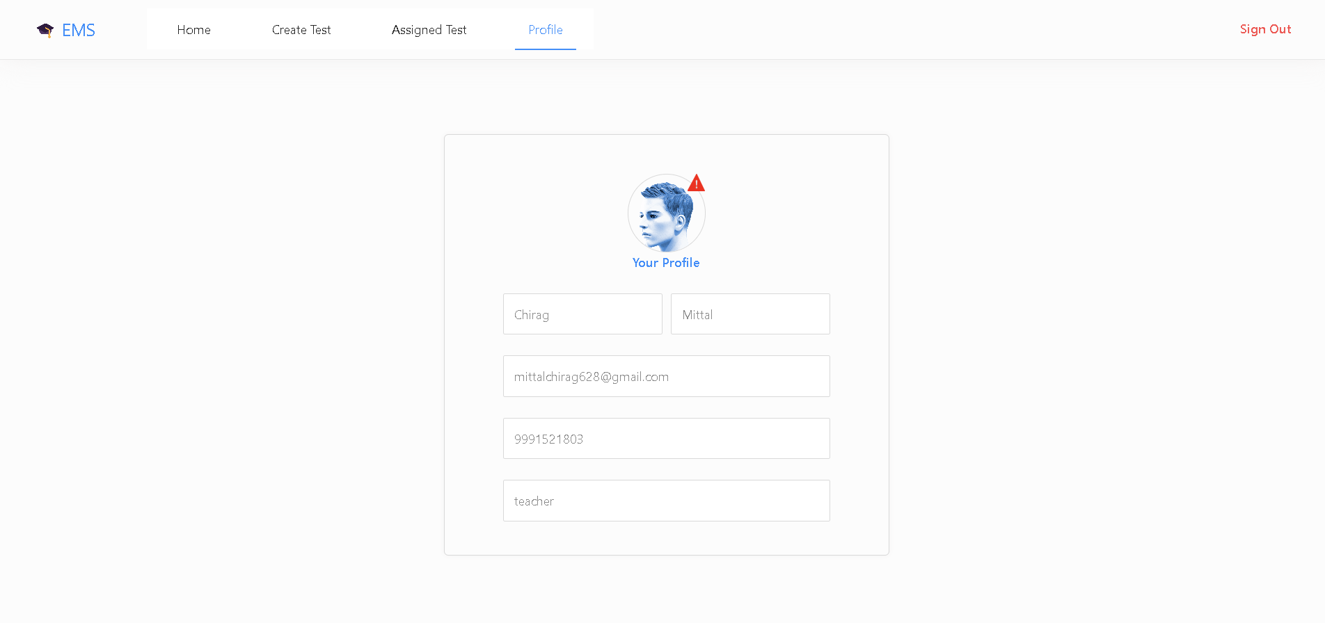

## 

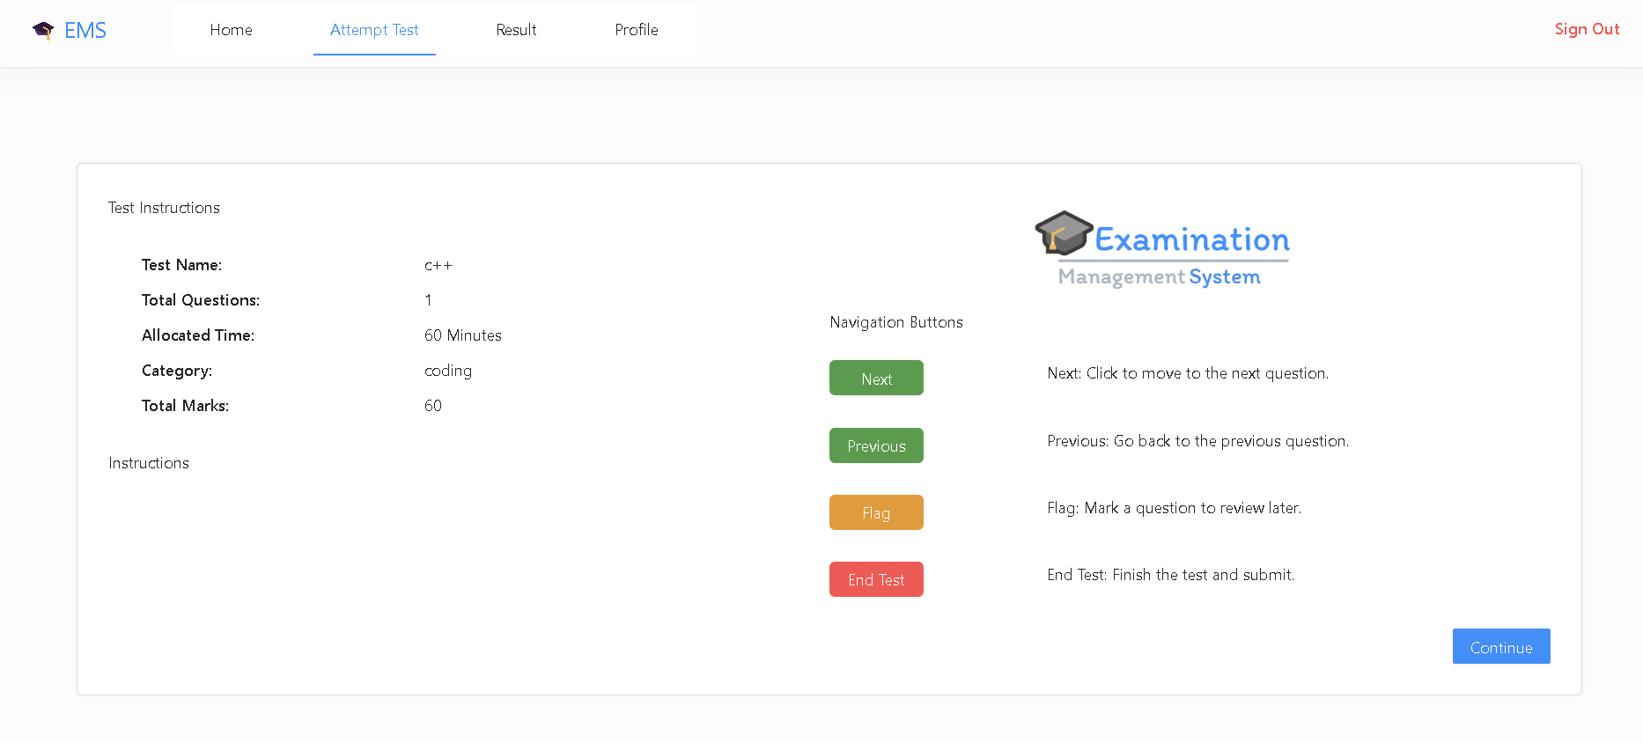

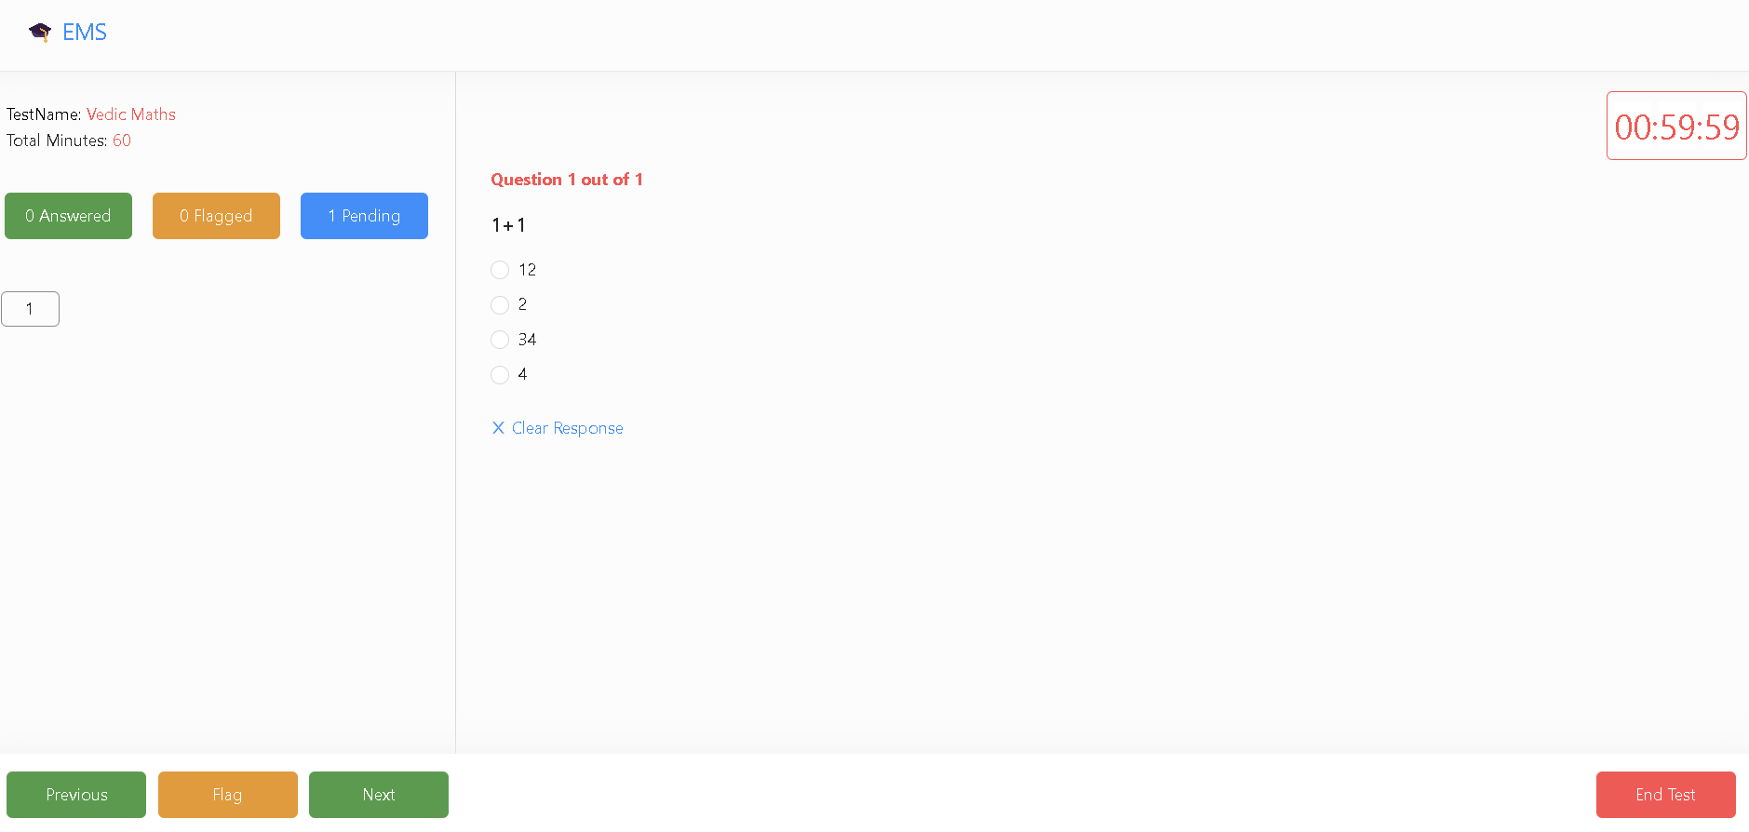

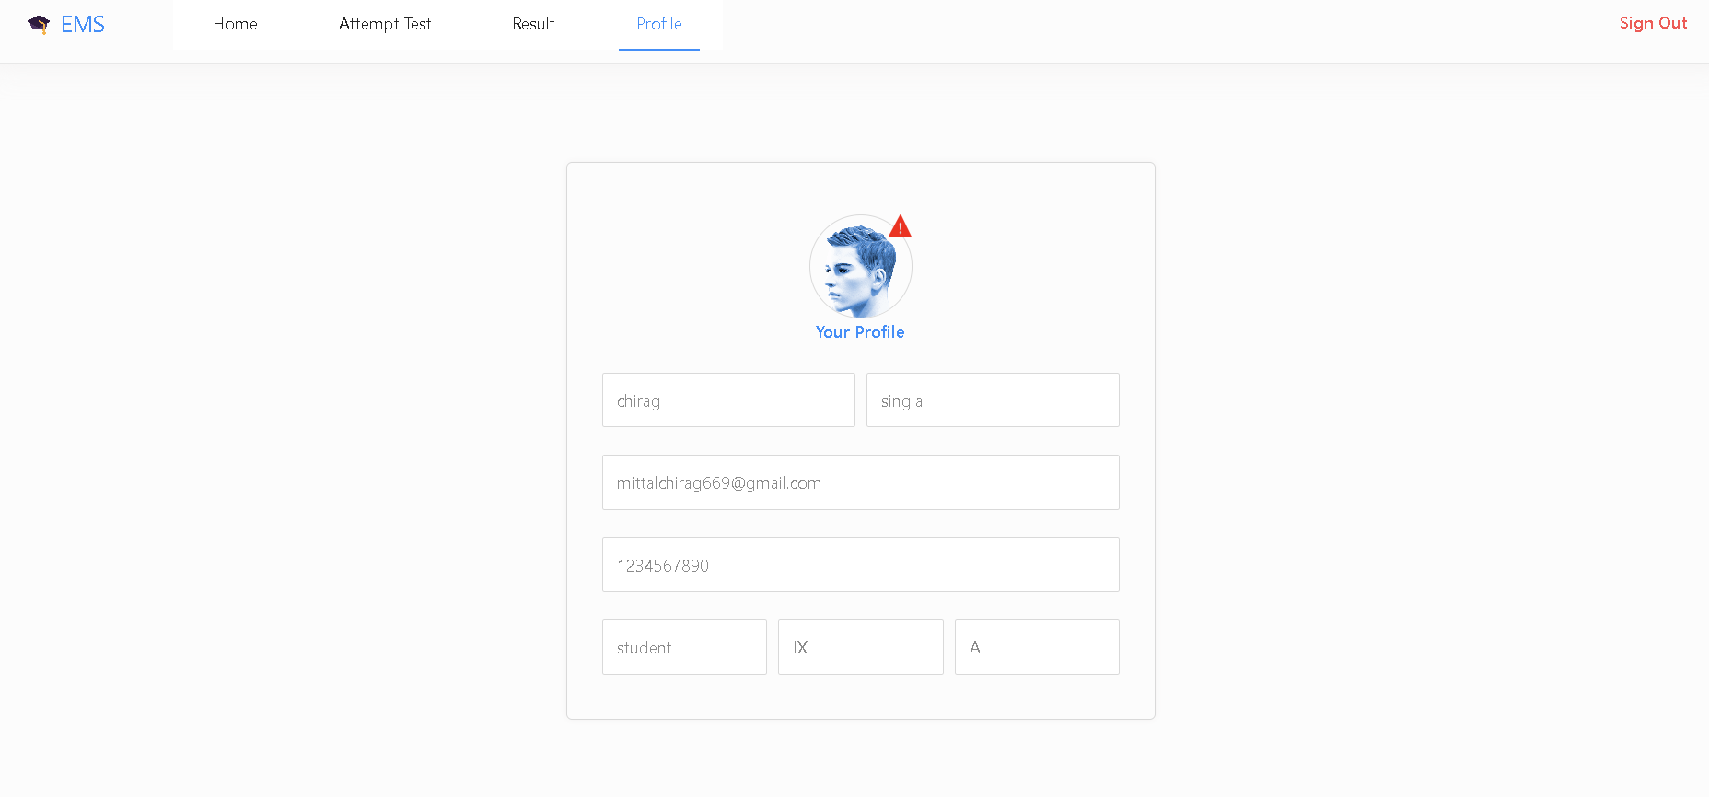

## 7 Limitations

* **Scalability:** The system may have limitations in handling large volumes of data or concurrent users.
* **Integration:** Integration with external systems may require additional development.
* **Security:** Implementing robust security measures is essential to protect sensitive user data.

## 8 Conclusion

The Online Examination Platform built using the MERN stack provides an efficient and scalable solution for conducting online assessments. The system offers distinct roles for Admins, Examiners, and Students, ensuring smooth course and test management. Admins can manage courses and assign examiners, Examiners can create and modify tests with CRUD operations on questions, and Students can take tests and view their results. The platform ensures secure authentication, real-time performance tracking, and automated grading for MCQs, making the examination process seamless and user-friendly.

## 9 Future Scope

* Cheating Prevention – Implementing AI-powered proctoring, screen monitoring, and plagiarism detection to ensure fair examination practices.
* Charts for Results – Enhancing the platform with graphical analytics, including bar charts and pie charts, to help students and examiners visualize performance trends over time.
* Manual Checking of Questions – Introducing an option for examiners to manually evaluate subjective answers, ensuring fair grading for descriptive responses.
* Notification for Tests – Implementing email and in-app notifications to remind students about upcoming tests, deadlines, and important updates.
* Certificate Generation – Enabling automated certificate generation for students who successfully pass a test, with downloadable PDFs.
* Exam History Tracking – Allowing students to view their past test attempts, scores, and progress over time, aiding in self-assessment and improvement.

**10 References**

* <https://react.dev/>
* <https://www.mongodb.com/docs/>
* <https://expressjs.com/>
* <https://react-leaflet.js.org/docs/start-introduction/>
* <https://www.tailwindcss-animated.com/>
* <https://react-icons.github.io/react-icons/>